**ANGULAR 4 CLIENT OF EXPRESS.JS SOCKET.IO SERVER**

REF:

<https://www.djamware.com/post/58e0d15280aca75cdc948e4e/building-chat-application-using-mean-stack-angular-4-and-socketio>

IN ORDER TO CONNECT OUR ANGULAR 4 FRONT-END WITH EXPRESS.JS SOCKET.IO SERVER, WE HAVE TO FOLLOW NEXT INSTRUCTIONS:

ANGULAR 4 CLI PROJECT:

1. INSTALL SOCKET.IO CLIENT: ***npm install socket.io-client –no-bin-links –save***

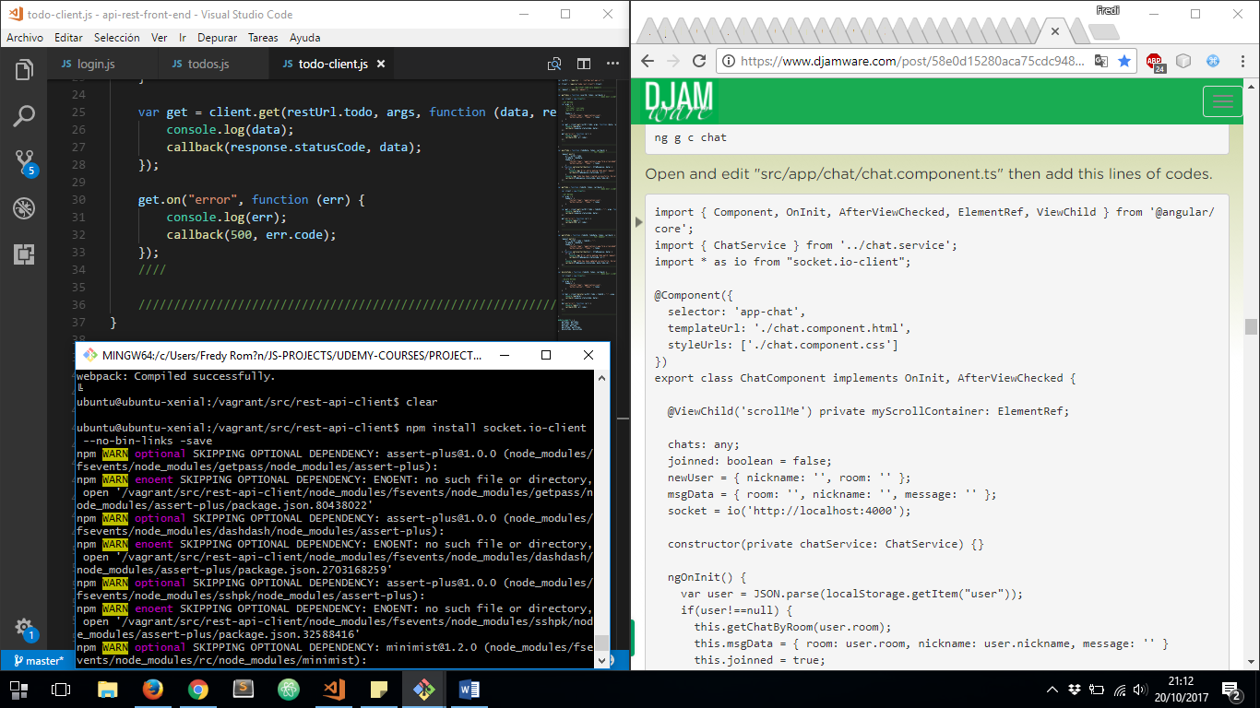

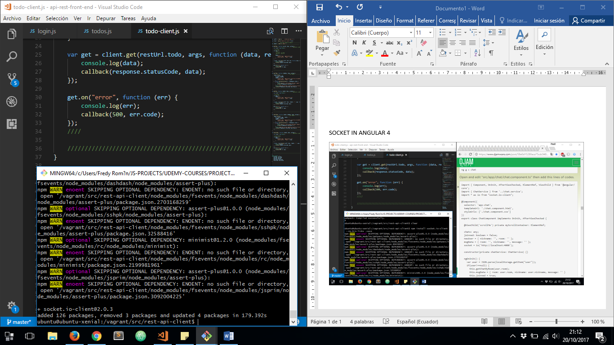

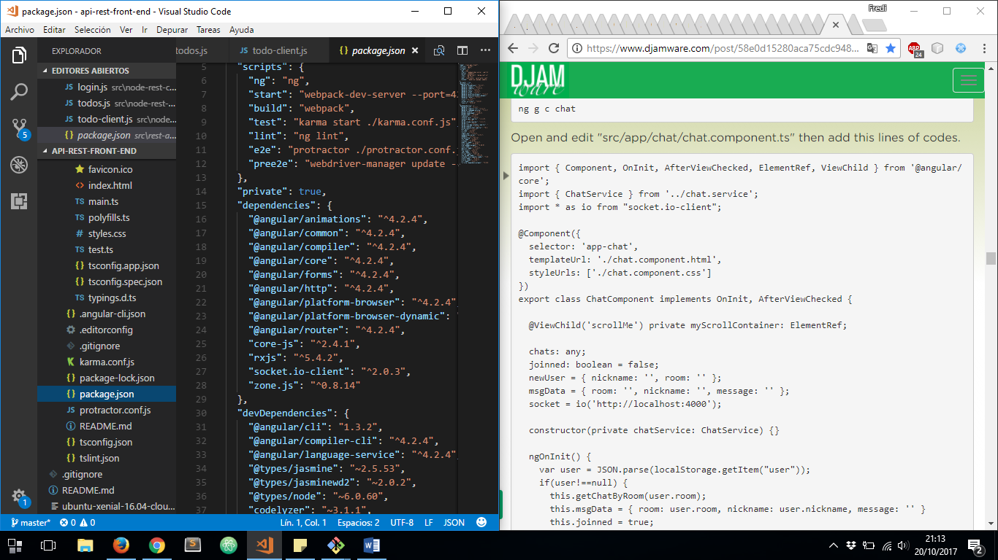

1. THEN, WE ARE READY TO USE ***socket.io-client*** MODULE ON OUR COMPONENT:

IMPORTING NPM MODULE ON ANGULAR 4 COMPONENT

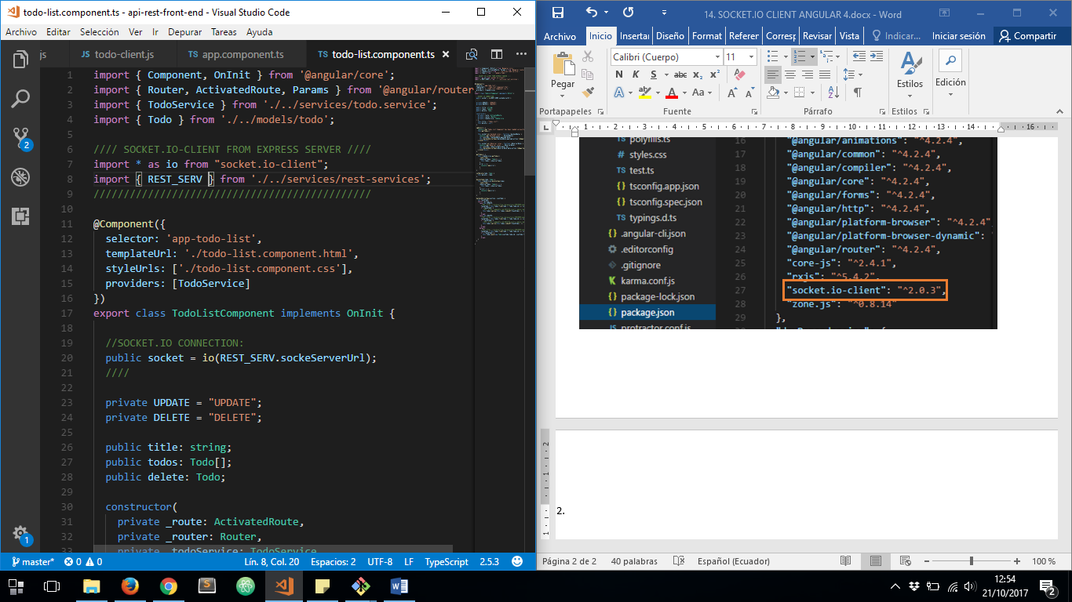

ESTABLISHING SOCKET.IO CONNECTION:

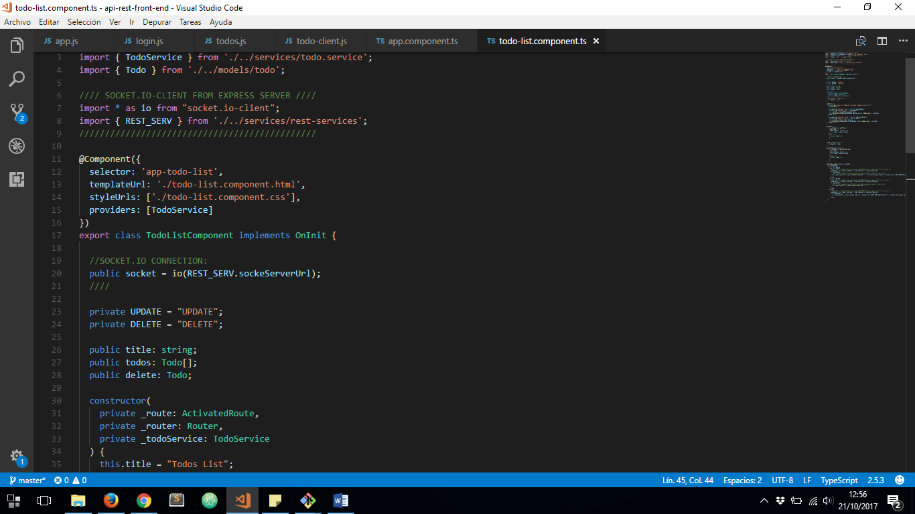

CATCHING BACKEND SERVER NOTIFICATIONS (POSTGRESQL PUB/SUB AND REST API CHANGES) ON FRONT END THROUGH EXPRESS.JS MIDDLEWARE SERVER:

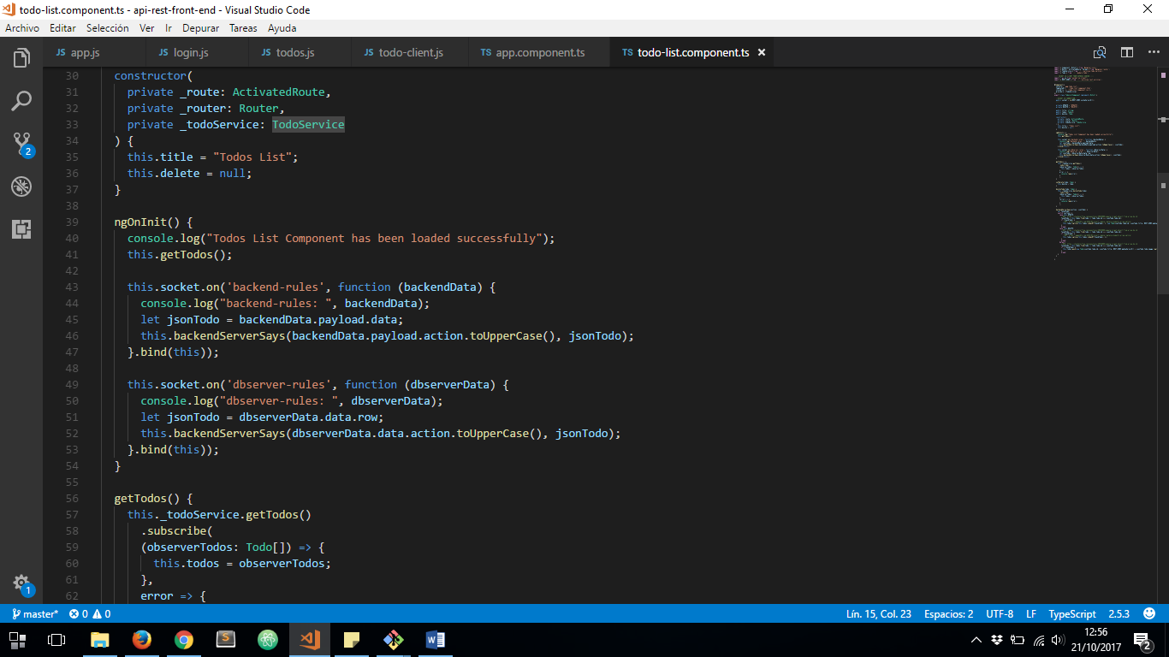

HANDLING COMMING DATA TO SHOW ON USER INTERFACE:

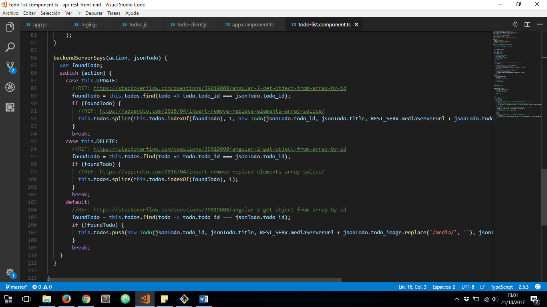

NOW LET’S TRY IT, MAKE SURE ALL SERVERS ARE RUNNING. LET’S MAKE CHANGES IN OUR DJANGO REST FRAMEWORK API DIRECTLY:

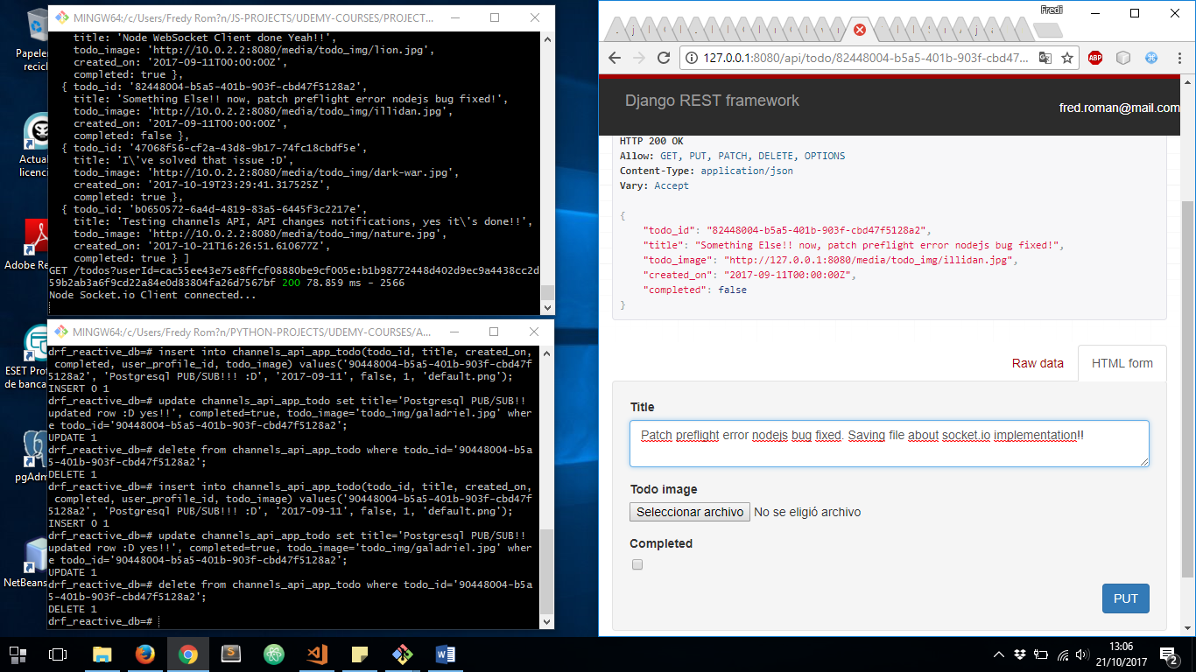

NOW SEE HOW NOTIFICATIONS COME FROM DJANGO CHANNELS WEBSOCKET TO EXPRESS.JS WEBSOCKET CLIENT:

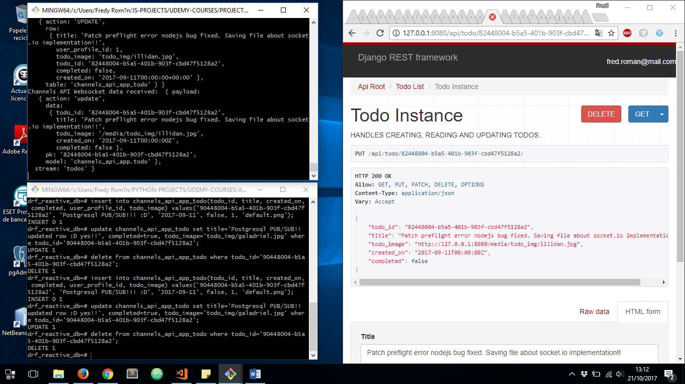

AND NOW LET’S SEE HOW SOCKET.IO NOTIFICATIONS COMMING FROM EXPRESS.JS MIDDLEWARE SERVER TO OUR FRONT-END CLIENT:

